**ID – hrajranj**

**Day 16 – 09th July 2025**

Wap to find the factorial of a number

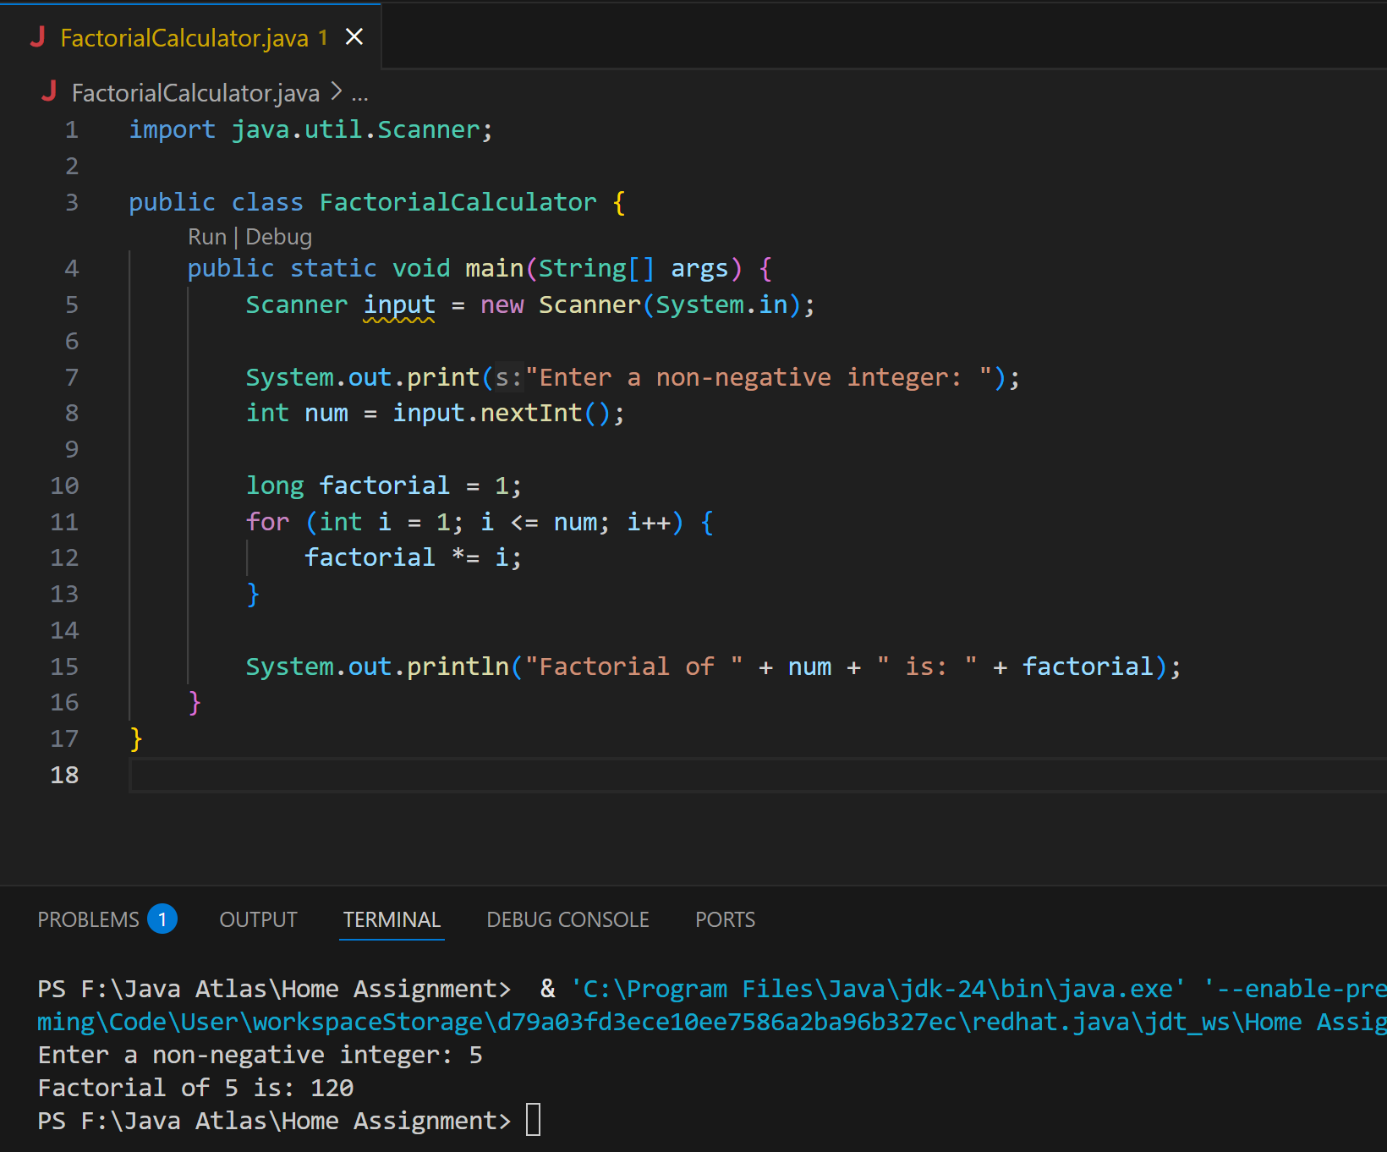

Wap to find the Fibonacci series of a number

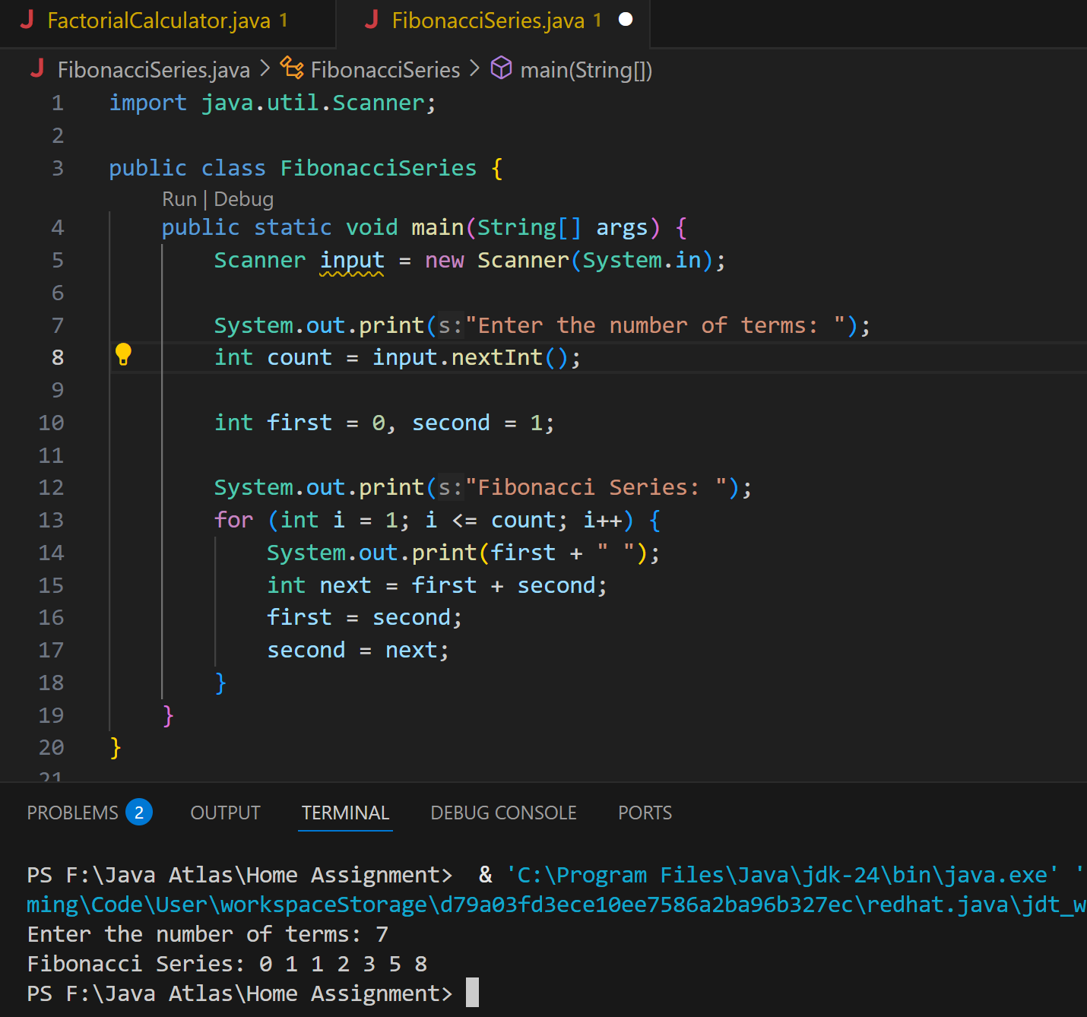

What is the difference between recursion and iteration

| **Feature** | **Recursion** | **Iteration** |
| --- | --- | --- |
| 💡 Definition | A method calls itself to solve smaller instances | Uses loops (like for, while) repeatedly |
| 🔁 Flow | Breaks the problem into sub-problems (smaller calls) | Repeats steps until a condition is met |
| 📦 Memory usage | More memory (uses call stack for each method call) | Less memory (single loop, minimal stack usage) |
| 🚨 Risk | Risk of **stack overflow** if too many calls | Risk of **infinite loops** if condition fails |
| 🔄 Example | Factorial via fact(n) = n * fact(n-1) | Factorial using a loop from 1 to n |
| 🧠 Readability | Sometimes more elegant, especially for tree problems | Usually easier to trace and debug |

Wap to reverse a string using recursion..

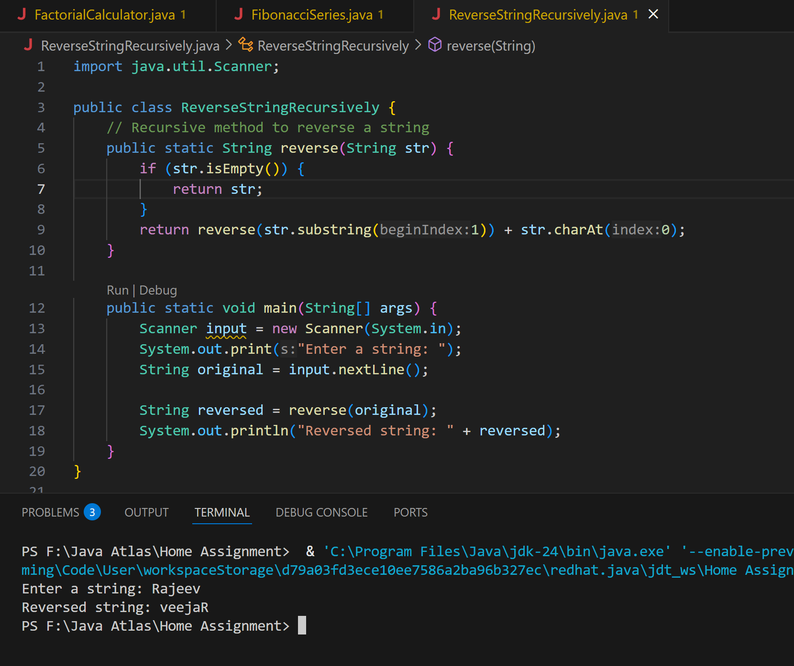

Write a recursive function to search for an element in an array

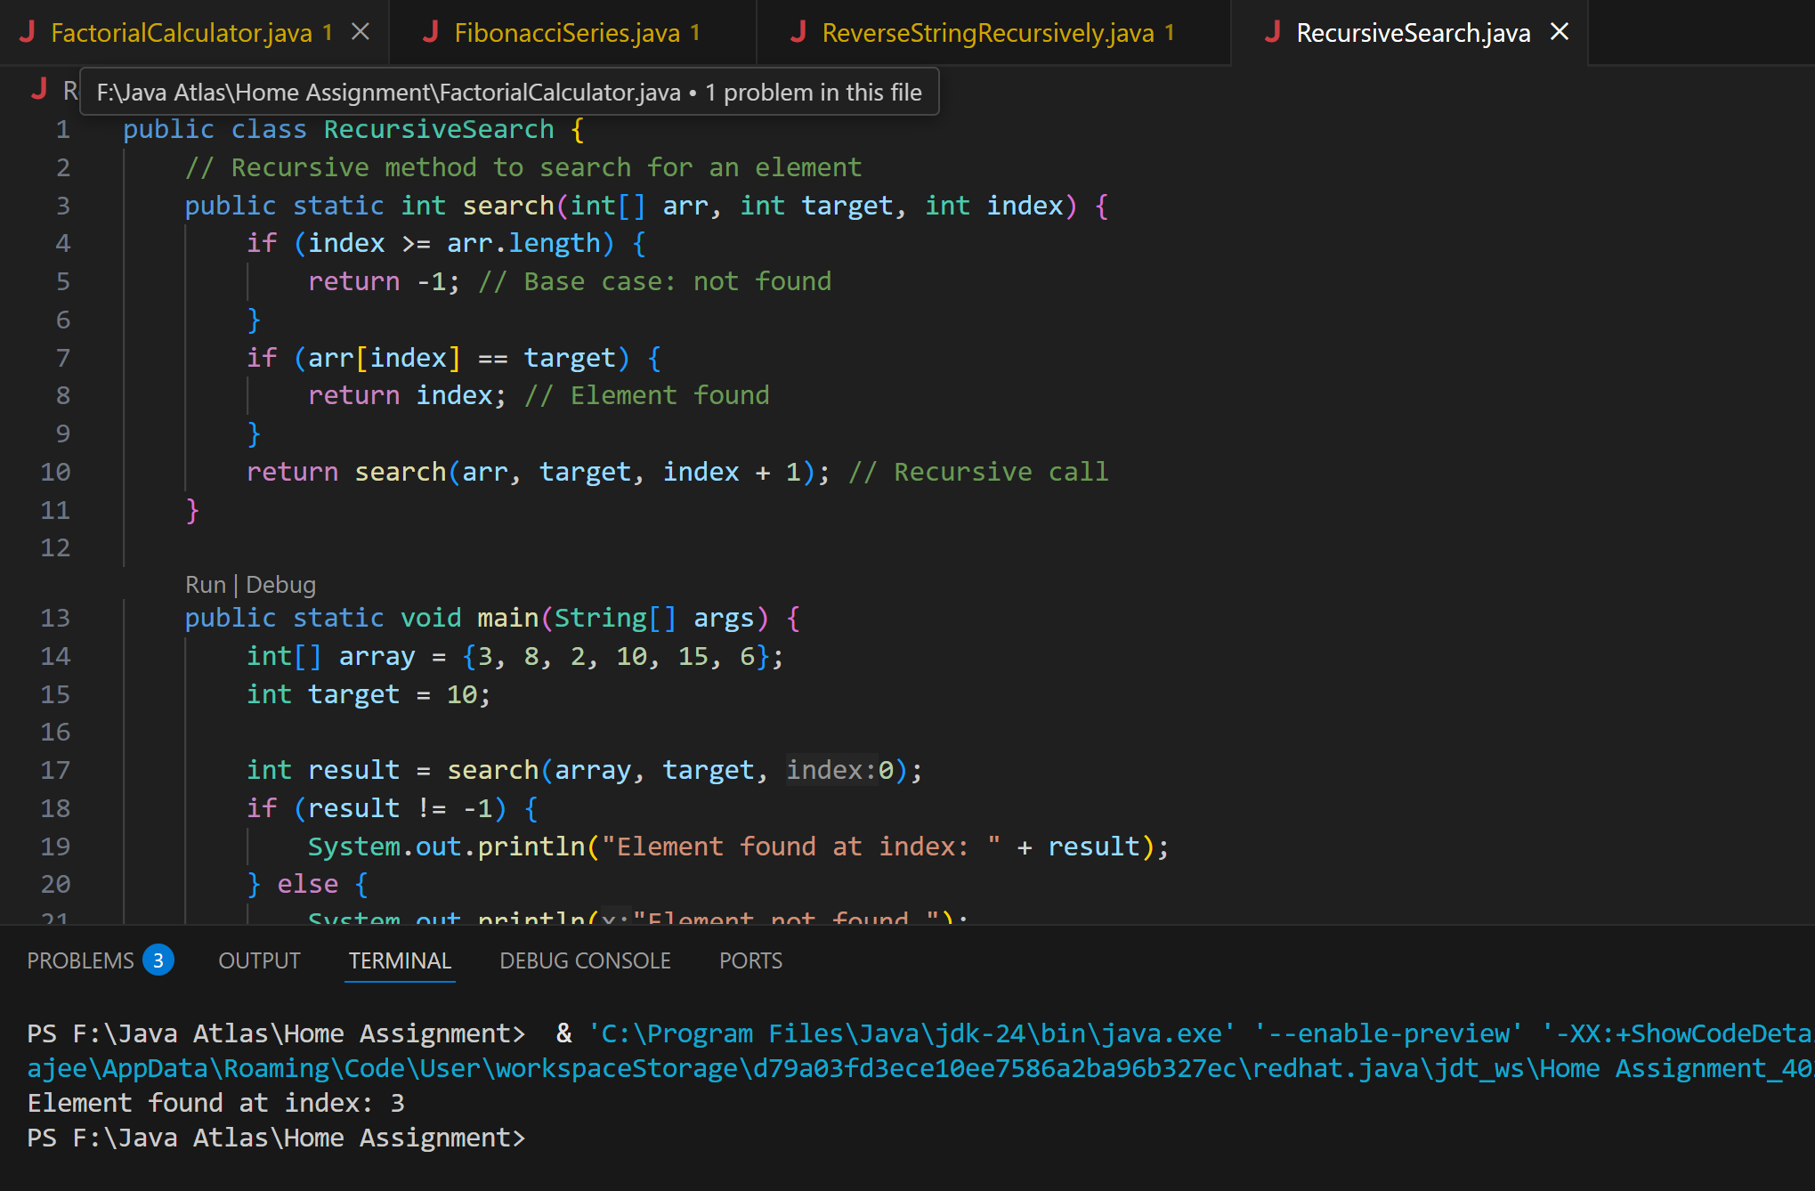

2. Write a recursive function to count the digits of a positive integer (do also for sum of digits)

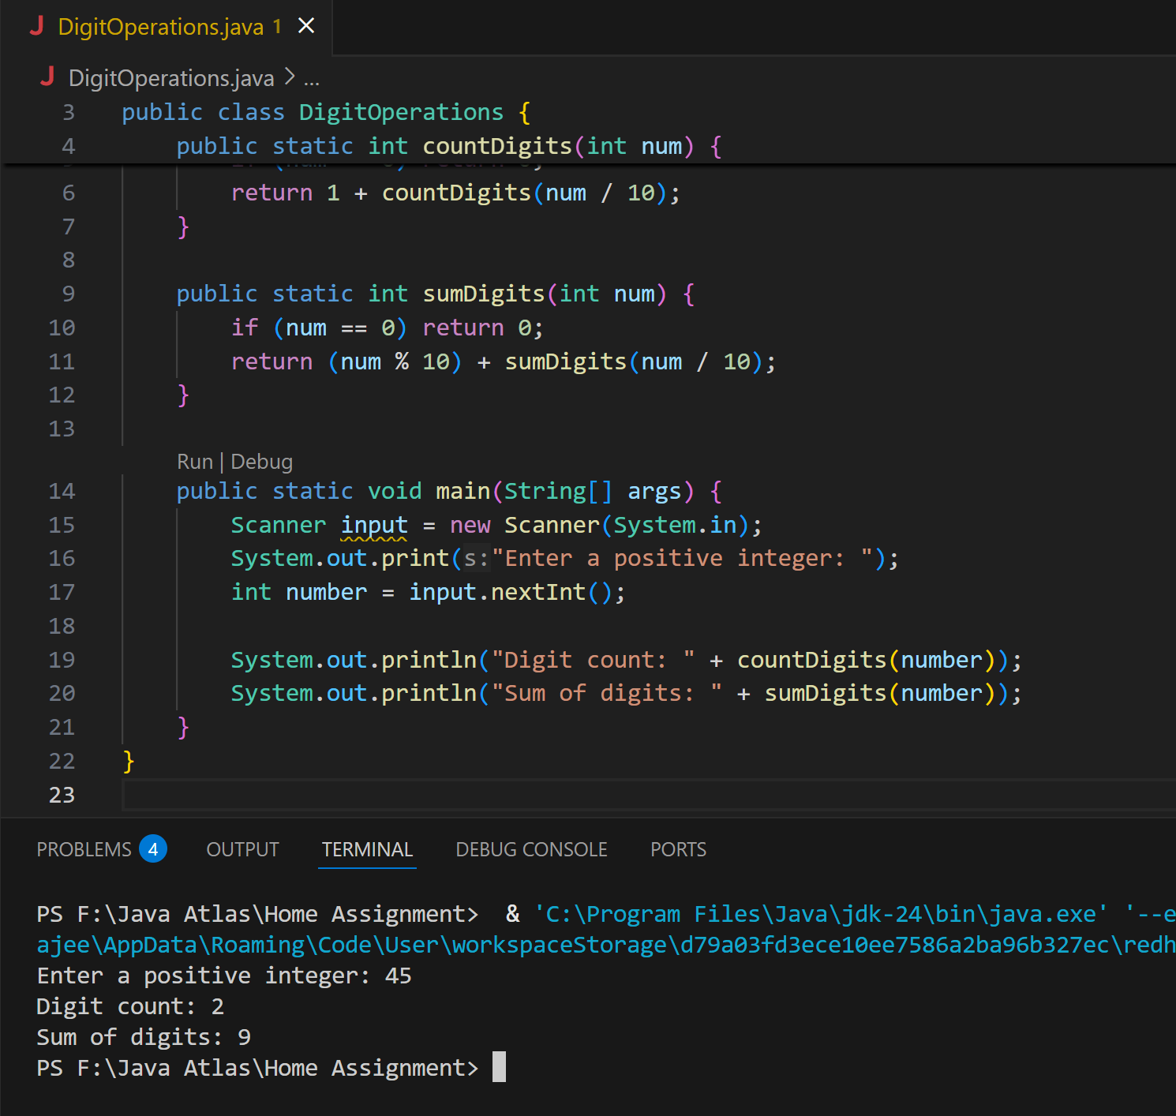

3. Write a recursive function to reverse a null-terminated string

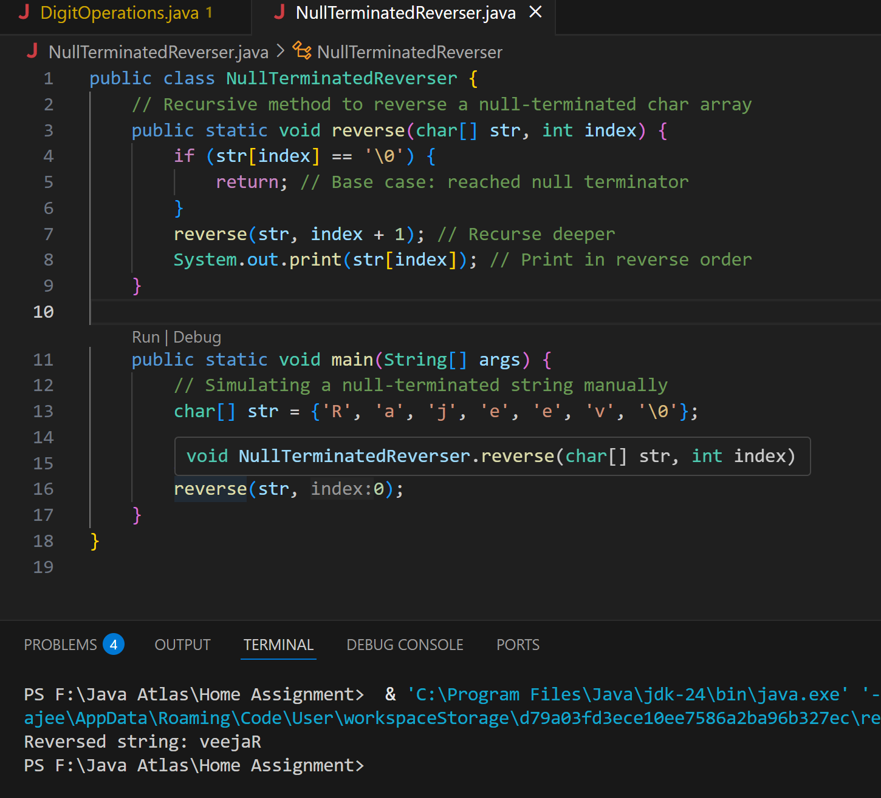

4. Write a recursive function to convert a decimal number to binary

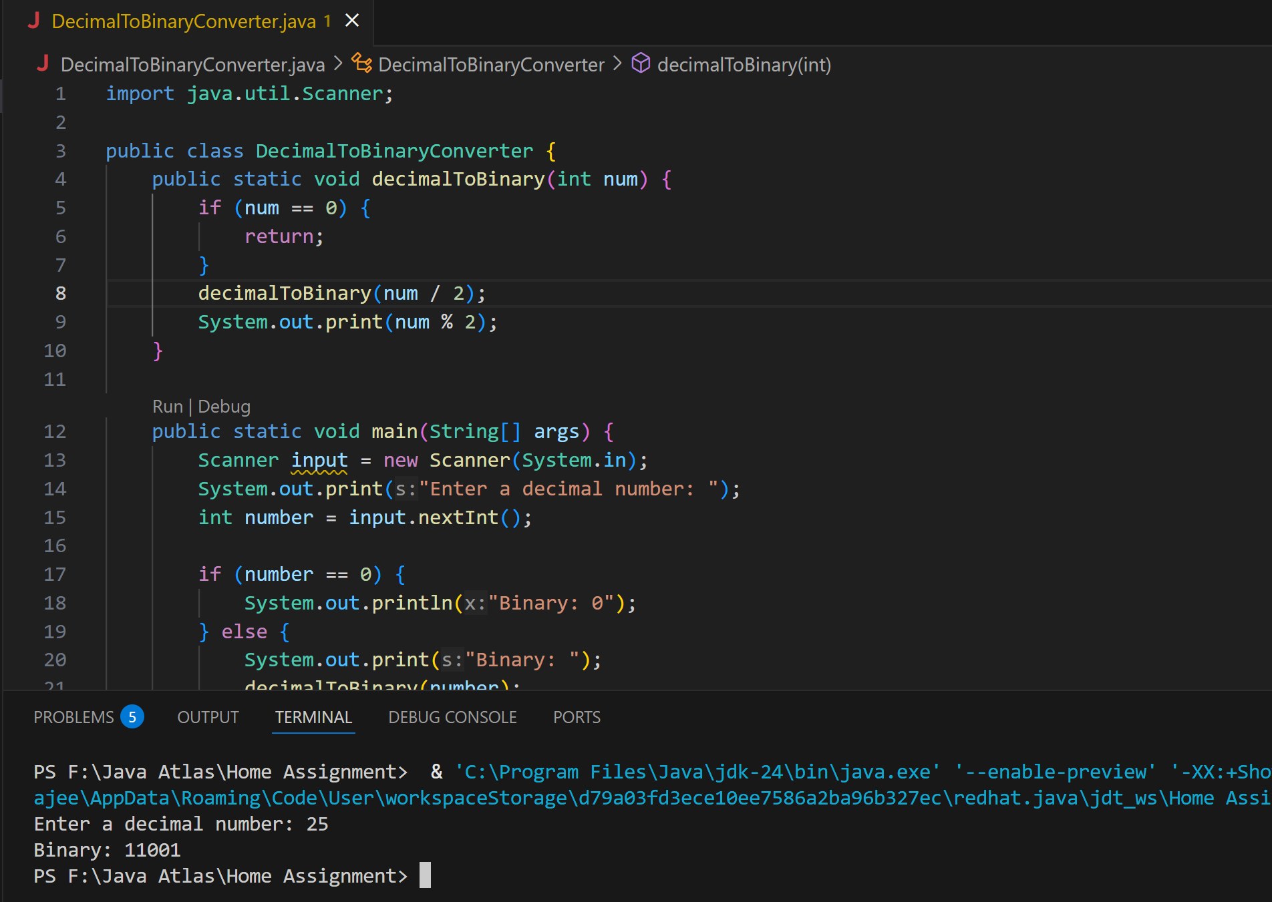

5. Write a recursive function to check if a string is a palindrome or not

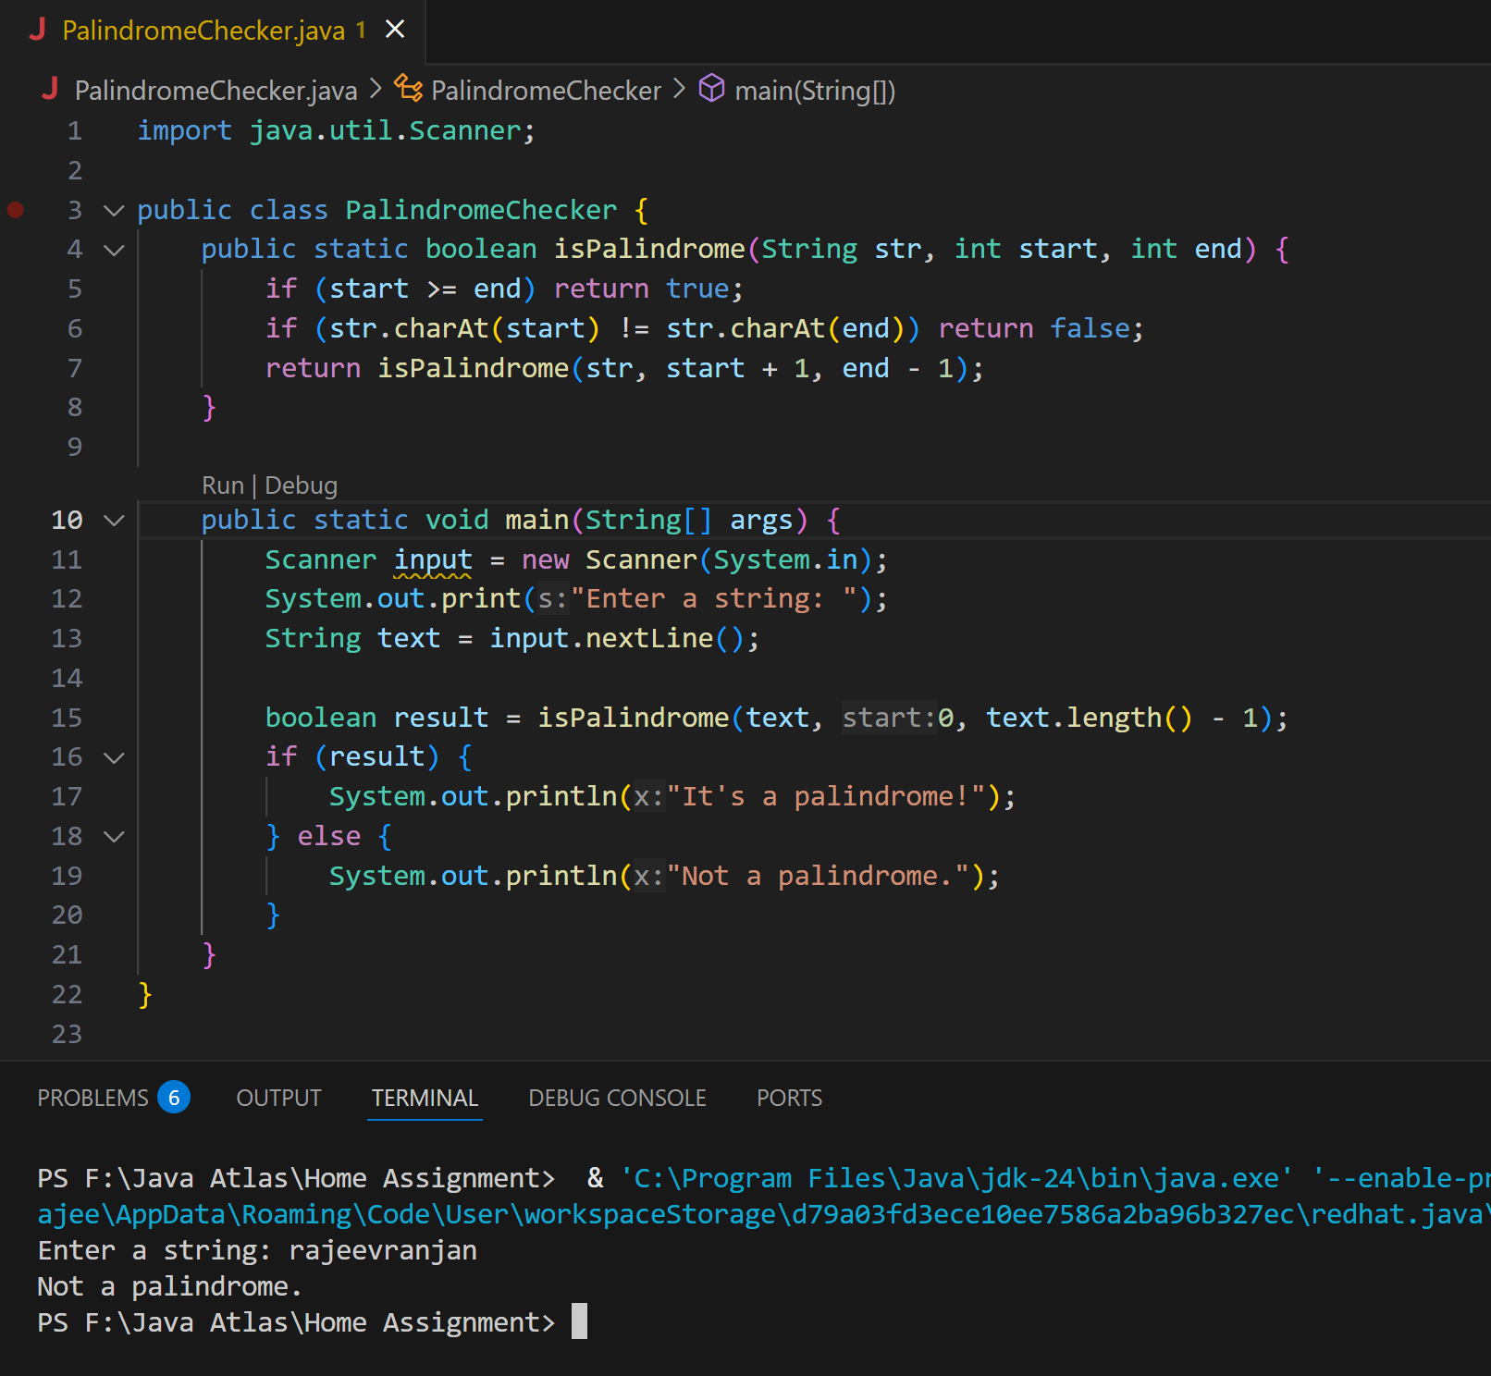

6. Write a recursive function to copy one array to another

